International Study Tour Deposit Directions

1. Go to the Cashier's Office in the Student Services Center.

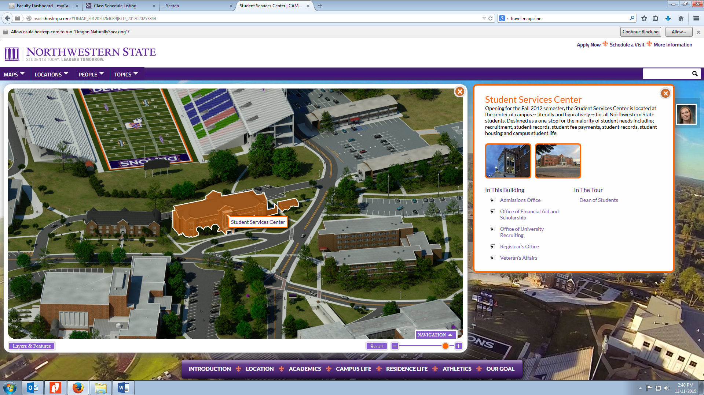

2. Tell the cashier that you need to deposit funds for the International Study Tour and give them the following information:
International Study Tour -
Banner Fund 274002
Org 227115
Program 10
Account Code 510649

3. Bring your receipt to Mrs. Salter!! If you do not bring your receipt to Mrs. Salter, we have no way of knowing who has paid and who has not!
You can slip the receipt under my door if I am not in my office, or give it to our Administrative Assistant, Mrs. Ann Spillman, Room 132 FACS Building.

